

Hard Level Programs (1-15)

Date – 19/03/2026

Name: M. Sahasra
Reg. No.: 192425317
Course Code: CSA0919
Course Name: Programming in Java for Spring Framework
Faculty Name: Dr. Magesh Kumar

1. Days → Years, Weeks, Days

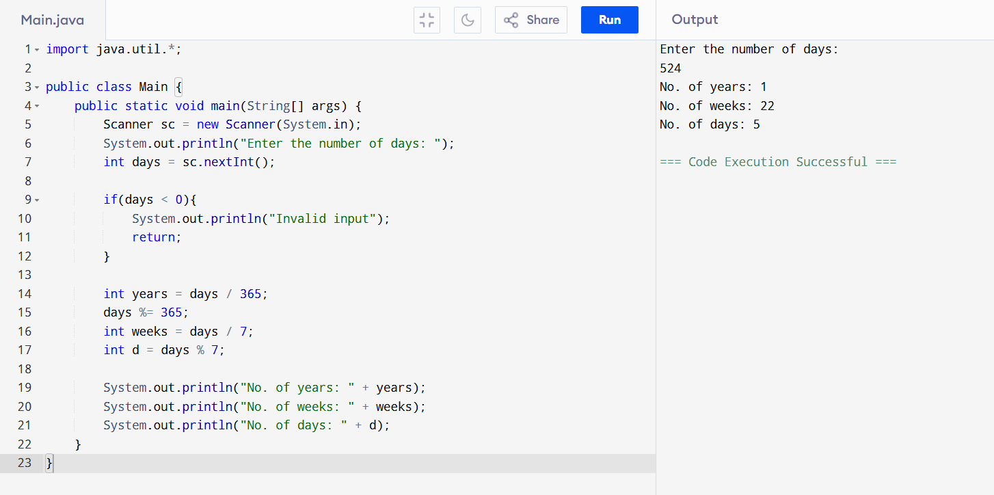

1(b). Day of the Week
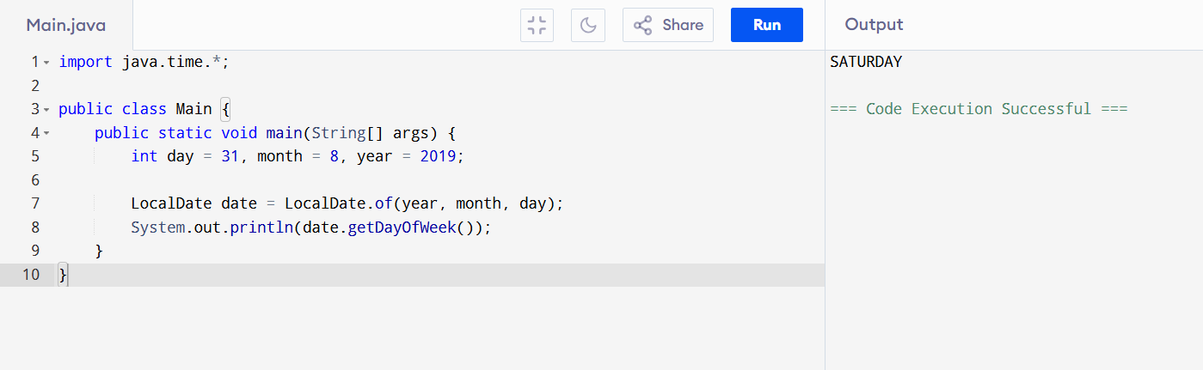
2. Student Users
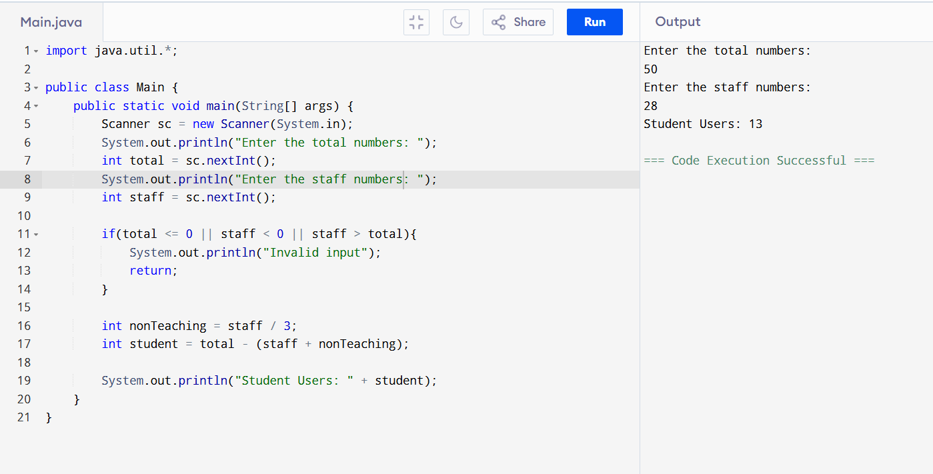
3. Factors + Nth Factor
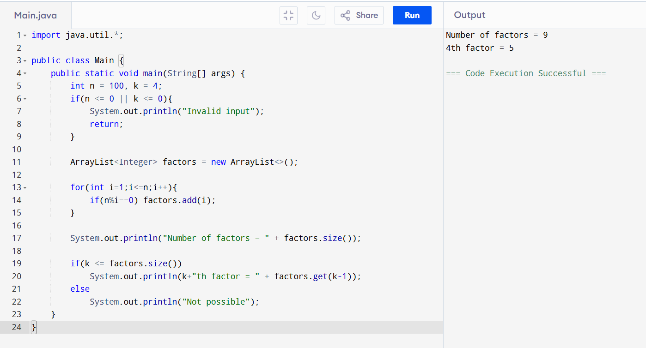
4. Nth Prime + Next N Primes

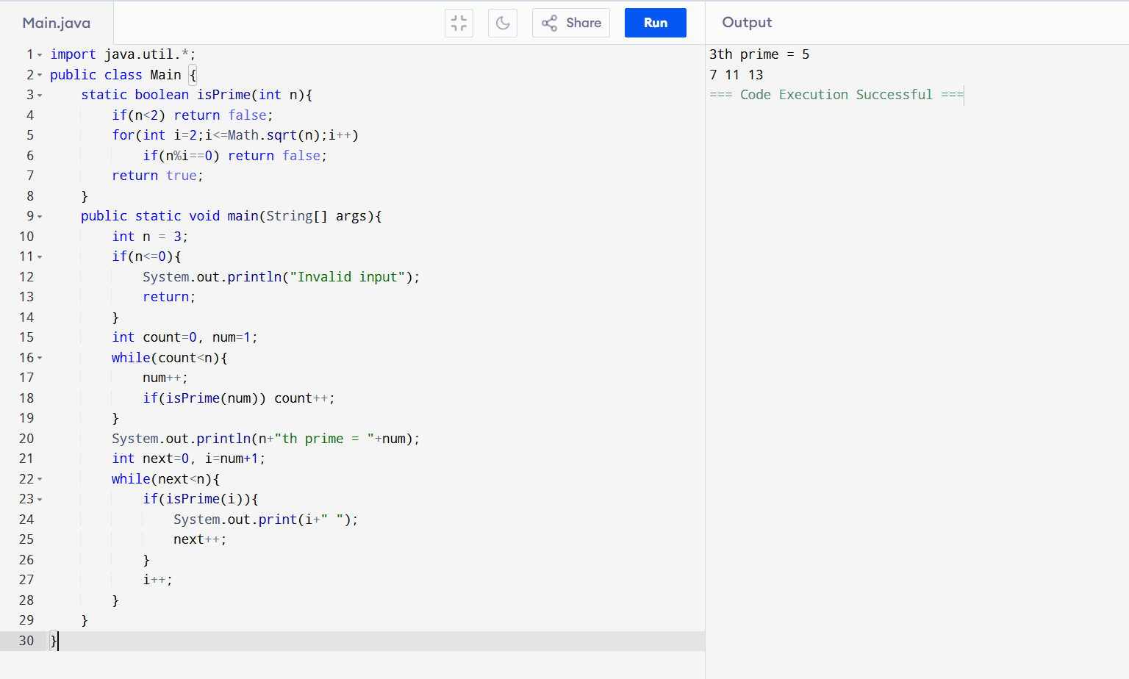

5. Perfect Squares + Digit Sum < 10

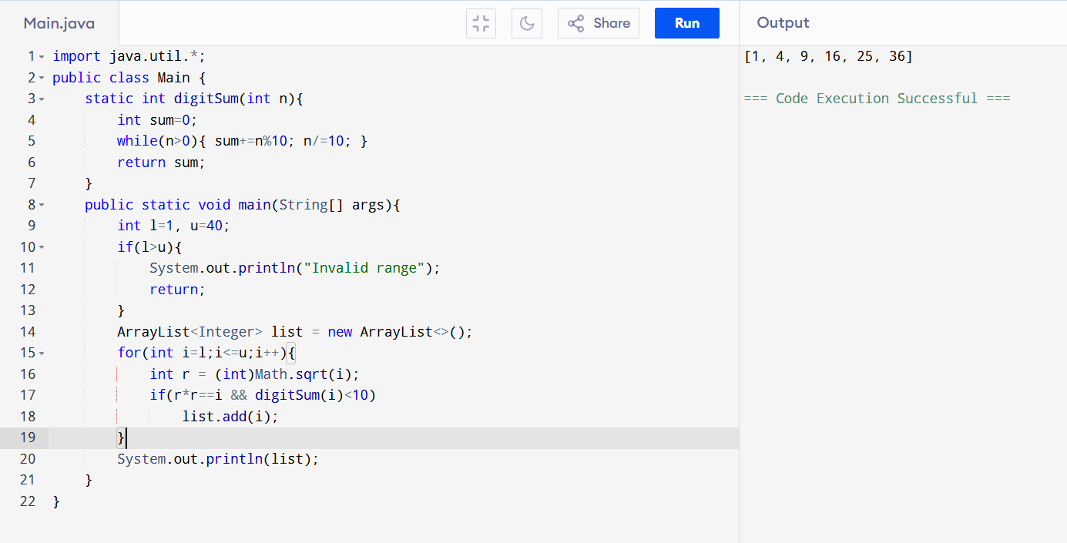

6. Unique Permutations

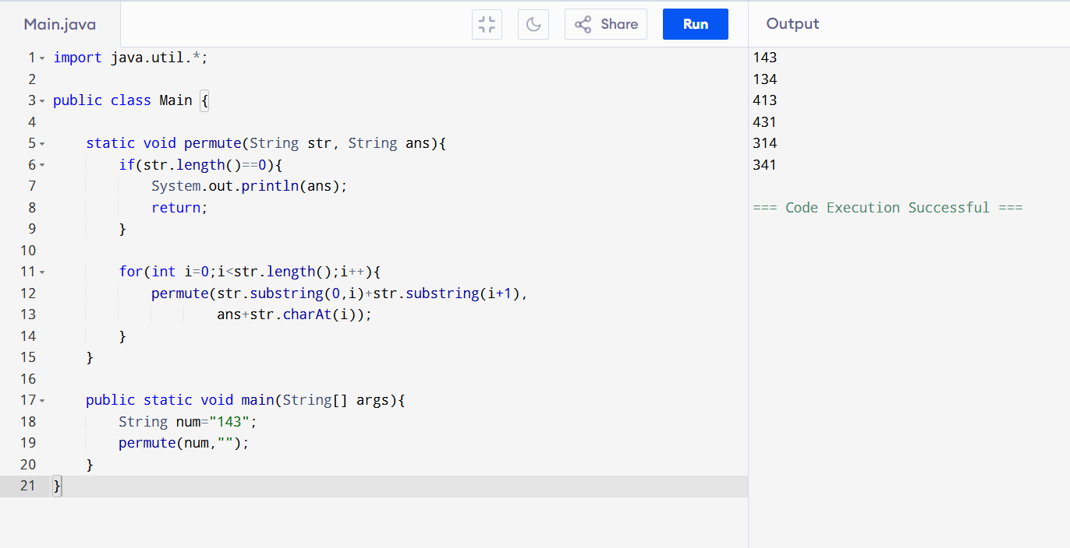

7. Number + Square Array

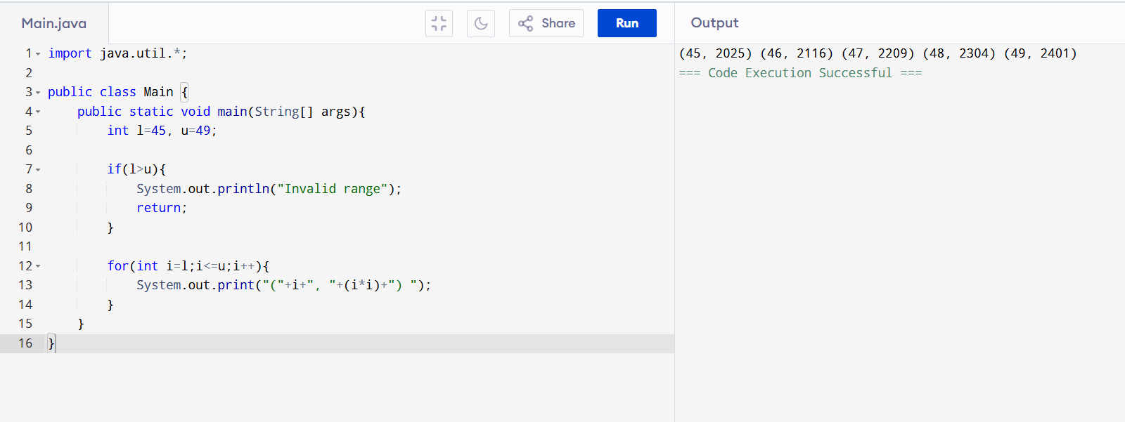

8. Bank Account

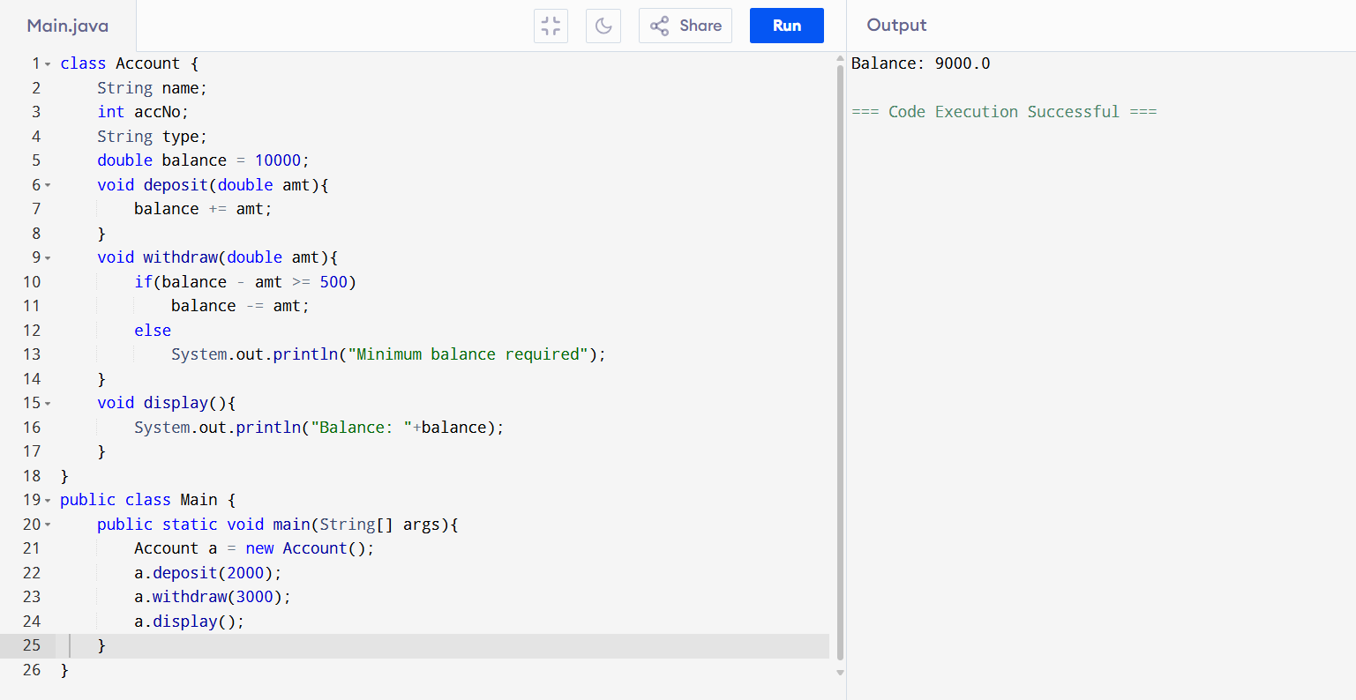

9. Reverse & Add Palindrome

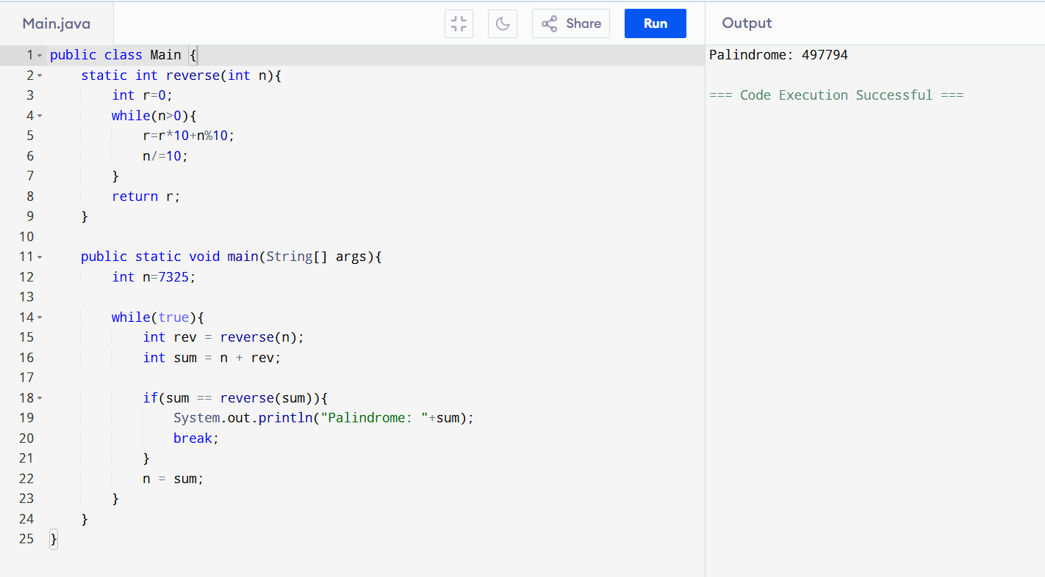

10. Synchronization (Simple Version)

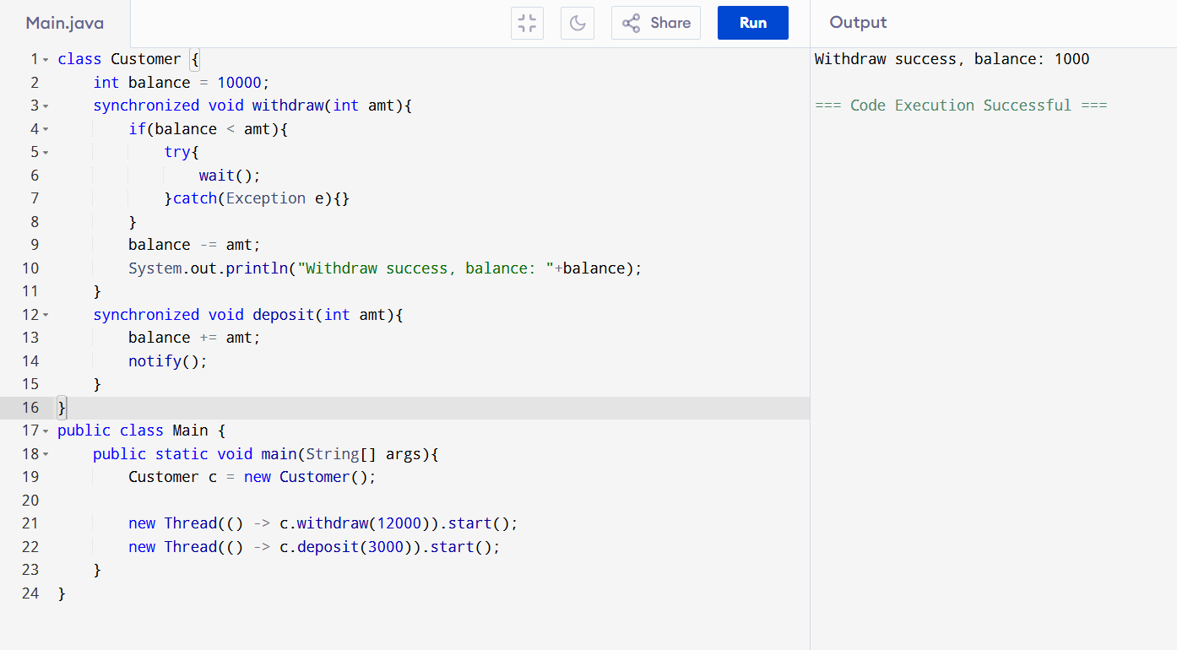

11. FizzBuzz

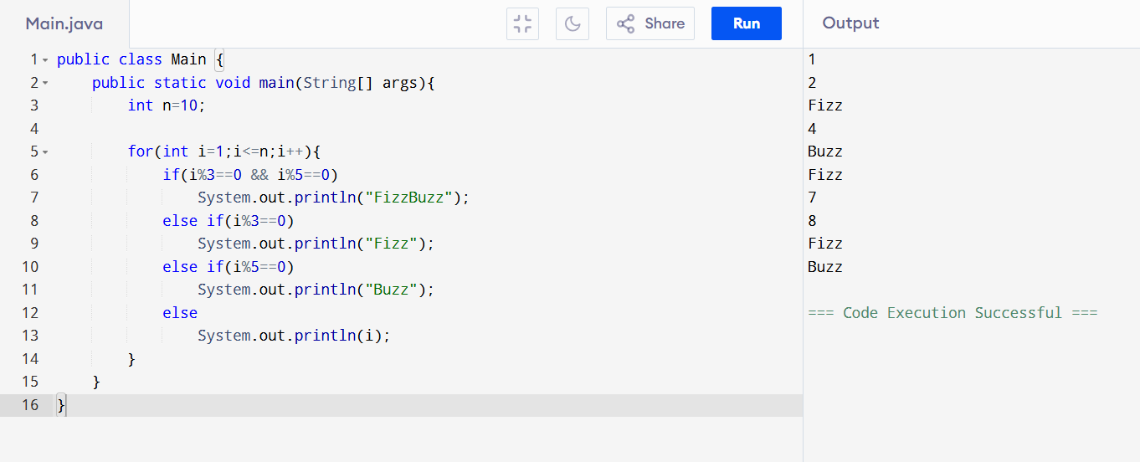

12. Common Elements in Arrays
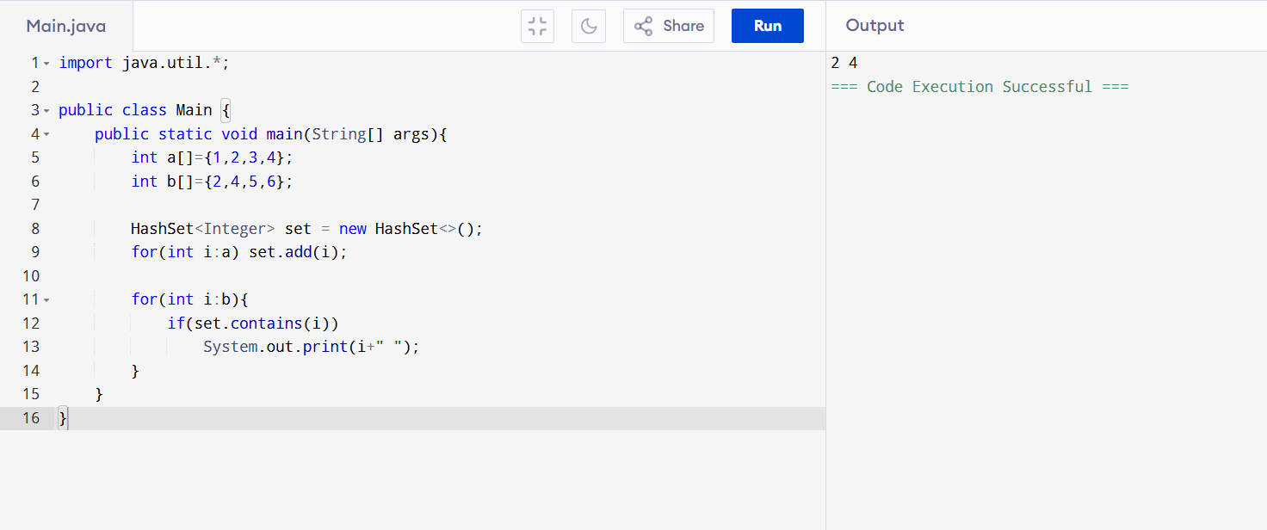

13. Length of Last Word
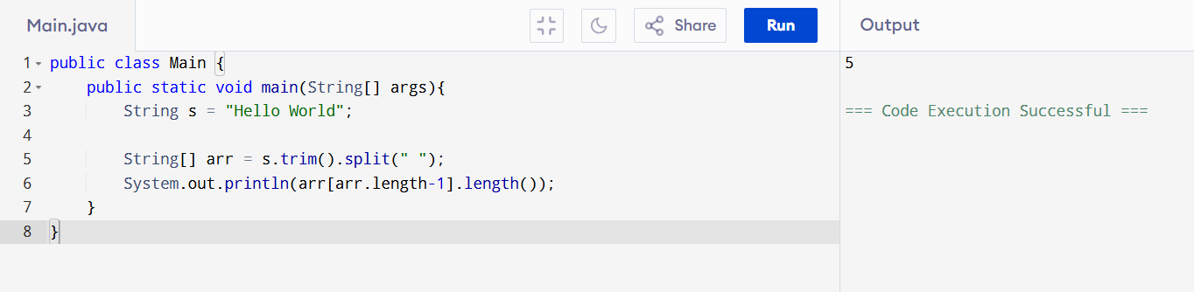

14. Roman to Integer
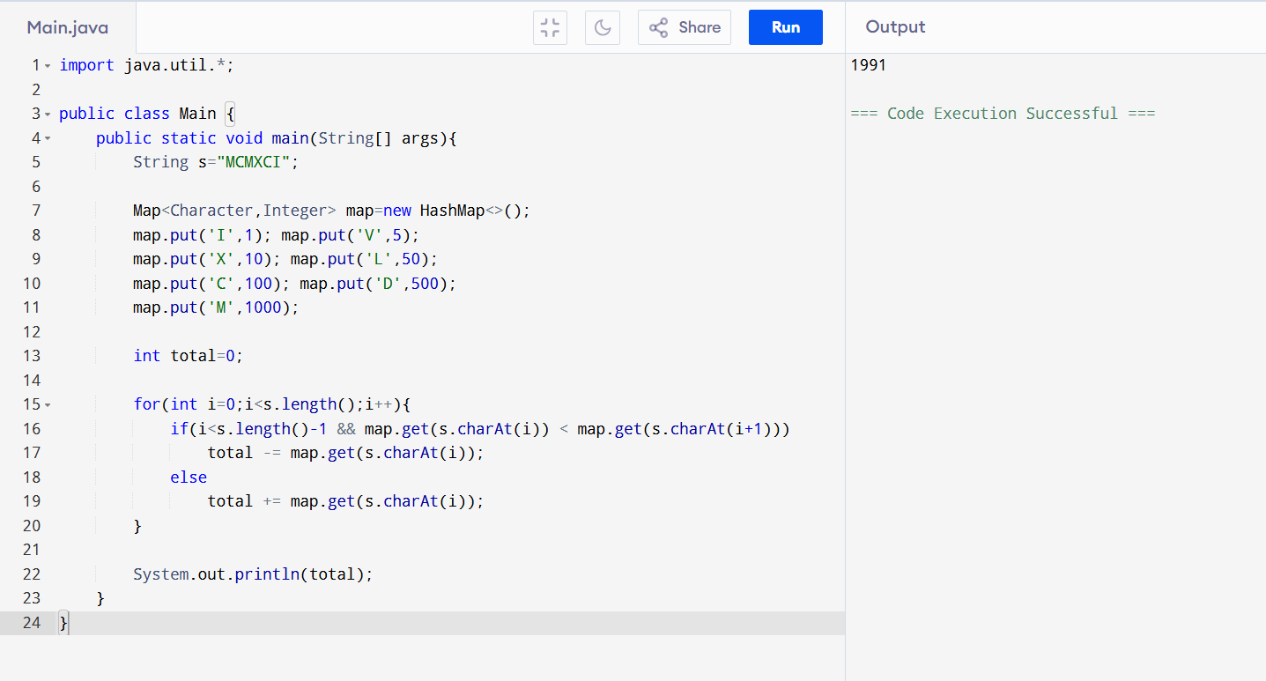
15. Ransom Note
